LAPORAN KEGIATAN
MUSYAWARAH GURU MATA PELAJARAN (MGMP)
Mata Pelajaran: BAHASA INGGRIS SMK
Semester: I ( GANJIL )
Tahun Pelajaran: 2026/2027

LEMBAR PENGESAHAN
Laporan kegiatan MGMP Mata Pelajaran Bahasa Inggris SMK telah dilaksanakan pada:

Hari/Tanggal : Kamis 10 September 2026

Tempat : Daring

Laporan ini disusun sebagai bentuk pertanggungjawaban pelaksanaan kegiatan MGMP Bahasa Inggris SMK

Dibuat Oleh,



Ketua MGMP Bahasa Inggris SMK Sekretaris

( IMRON ROSYIDI, S.Pd ) (FITRI ERAWATI, S.S.,M.Hum)
NIP. 198312012009041003 NIP. 197909012011032001

Mengetahui,
Kepala Cabang Dinas pendidikan
Wilayah kabupaten Aceh Tenggara

(JUFRI. RM,S.Pd.,M.Si)
NIP. 19700220 199801 1 001

BAB I
PENDAHULUAN
A. Latar Belakang
Musyawarah Guru Mata Pelajaran (MGMP) merupakan forum profesional bagi guru untuk meningkatkan kompetensi, berbagi pengalaman, menyusun perangkat pembelajaran, dan menyelesaikan berbagai permasalahan pembelajaran.
Melalui kegiatan MGMP diharapkan terjalin kerja sama yang baik antar guru sehingga kualitas pembelajaran semakin meningkat.

B. Dasar Pelaksanaan
- Undang-Undang Nomor 20 Tahun 2003 tentang Sistem Pendidikan Nasional.
- Peraturan Menteri Pendidikan yang berlaku mengenai pengembangan profesi guru.
- Program Kerja MGMP Tahun Pelajaran 2026/2027
- Hasil rapat pengurus MGMP Bahasa Inggris SMK

C. Tujuan
Meningkatkan kompetensi guru.
- Menyamakan persepsi dalam pelaksanaan pembelajaran.
- Menyusun perangkat ajar bersama.
- Menyusun asesmen yang berkualitas.
- Menjalin kolaborasi antar guru.

BAB II
PELAKSANAAN KEGIATAN
Nama Kegiatan : Pertemuan Rutin MGMP Bahasa Inggris SMK
Hari/Tanggal : Kamis / 10 September 2026
Waktu : 08.00 Wib s/d 14.30 Wib
Tempat : Daring
Jumlah peserta : 13 orang (Absensi Terlampir)
Terdiri dari guru-guru mata pelajaran Bahasa Inggris dari sekolah-sekolah anggota MGMP Bahasa Inggris SMK.

Susunan Acara
08.00–08.30 Registrasi Peserta/Pengisian Absensi Hadir.

08.30–08.45 Pembukaan

08.45–09.00 Sambutan Ketua MGMP

09.00–10.30 Penyampaian Materi

10.30–12.00 Diskusi

12.00–13.00 Istirahat

13.00–14.30 Pembahasan Indikator Soal TKA

14.30–15.00 Penutup

BAB III
HASIL PERTEMUAN
A. Materi yang Dibahas
- Evaluasi program kerja MGMP.
- Membahas Indikator Soal TKA
B. Hasil Keputusan
- Menyusun bank soal bersama.
- Menentukan agenda MGMP bulan berikutnya.
C. Rencana Tindak Lanjut
- Guru menyusun bank soal.
- Melakukan evaluasi pada pertemuan berikutnya.

BAB IV
PENUTUP

Kegiatan MGMP telah berlangsung dengan baik dan lancar. Seluruh peserta mengikuti kegiatan secara aktif sehingga tujuan pertemuan dapat tercapai.
Diharapkan hasil pertemuan ini dapat diterapkan dalam proses pembelajaran di sekolah masing-masing serta menjadi dasar peningkatan kualitas pendidikan secara berkelanjutan.

LAMPIRAN - LAMPIRAN
- Dokumentasi Foto
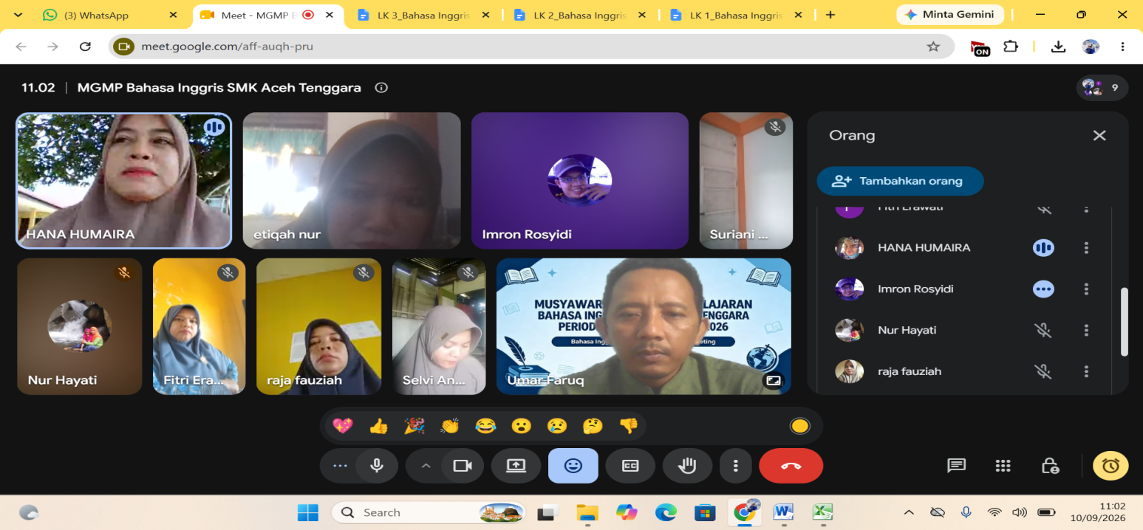

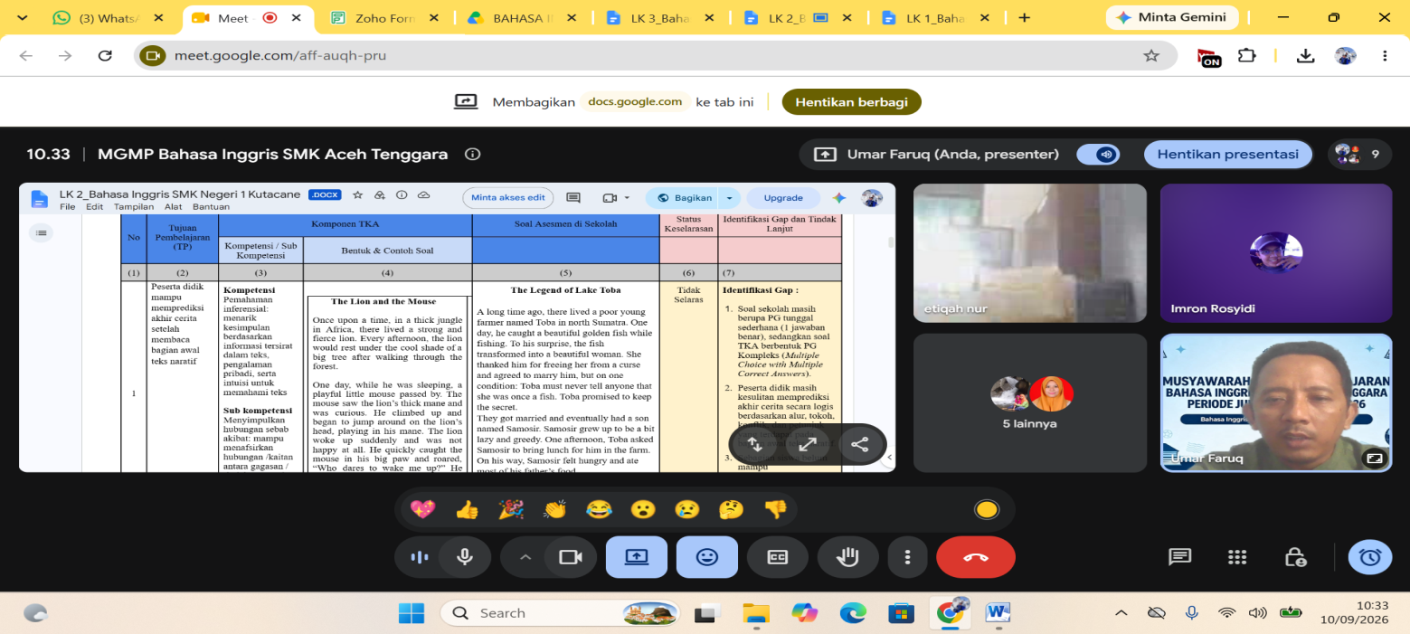

- Pembahasan Soal TKA
- DESCRIPTIVE TEXT
KARTU SOAL NOMOR 1

Mata Pelajaran : Bahasa Inggris
Fase/Kelas : F / XI

- Tujuan Pembelajaran: Peserta didik mampu mengidentifikasi detail spesifik dan karakteristik geografis dari teks deskriptif.
- Materi: Descriptive Text (Natural Landmarks).
- Indikator Soal: Disajikan teks deskripsi tentang tempat wisata, peserta didik dapat menentukan ciri khas ekosistem wilayah tersebut.
- Level Kognitif: L2 (Aplikasi/Pemahaman Mendalam).
- Bentuk Soal: MCMA (Pilihan Ganda Kompleks / Checkbox).

The Raja Ampat Archipelago
Located off the northwest tip of Bird's Head Peninsula in West Papua, Raja Ampat, or the Four Kings, is an archipelago comprising over $1,500$ small islands, cays, and shoals surrounding the four main islands of Misool, Salawati, Batanta, and Waigeo. It is often described as a "biological hotspot." The marine life diversity is staggering, boasting the highest recorded marine life diversity on Earth. Underwater, the visibility is crystal clear, revealing vibrant coral gardens that provide a sanctuary for pygmy seahorses, manta rays, and over a thousand species of reef fish. Above water, the karst topography creates dramatic limestone cliffs covered in lush tropical greenery, rising steeply from the turquoise sea.

Question: According to the description of Raja Ampat, what are the defining characteristics of this archipelago? (Select two correct answers)
[ ] It consists of thousands of islands centered around four primary landmasses.
[ ] It is characterized by a unique combination of karst landscapes and rich marine biota.
[ ] The region is primarily known for its volcanic activity and mountainous terrain.
[ ] The underwater environment is murky but contains rare deep-sea mammals.
[ ] Tourism is strictly prohibited in the area to preserve the delicate marine coral gardens.

Key Answers: A and B Explanation:
- A benar sesuai dengan kalimat pertama yang menyebutkan sekitar $1,500$ pulau kecil di sekitar $4$ pulau utama.
- B benar sesuai dengan penyebutan "karst topography" dan "highest recorded marine life diversity."
- C salah karena teks menekankan karst (bukan vulkanik).
- D salah karena visibilitas air disebutkan "crystal clear" (bukan murky).
- E salah karena tidak disebutkan dalam teks.

KARTU SOAL NOMOR 2

Mata Pelajaran : Bahasa Inggris
Fase/Kelas : F / XI

- Tujuan Pembelajaran: Peserta didik mampu mengidentifikasi karakteristik fisik objek wisata alam dari teks deskriptif.
- Materi: Descriptive Text.
- Indikator Soal: Disajikan teks deskripsi geologi, peserta didik dapat mengidentifikasi pembentukan purba kawasan tersebut.
- Level Kognitif: L2 (Aplikasi/Pemahaman Mendalam).
- Bentuk Soal: MCMA (Pilihan Ganda Kompleks / Checkbox).

The Stone Garden of Padalarang

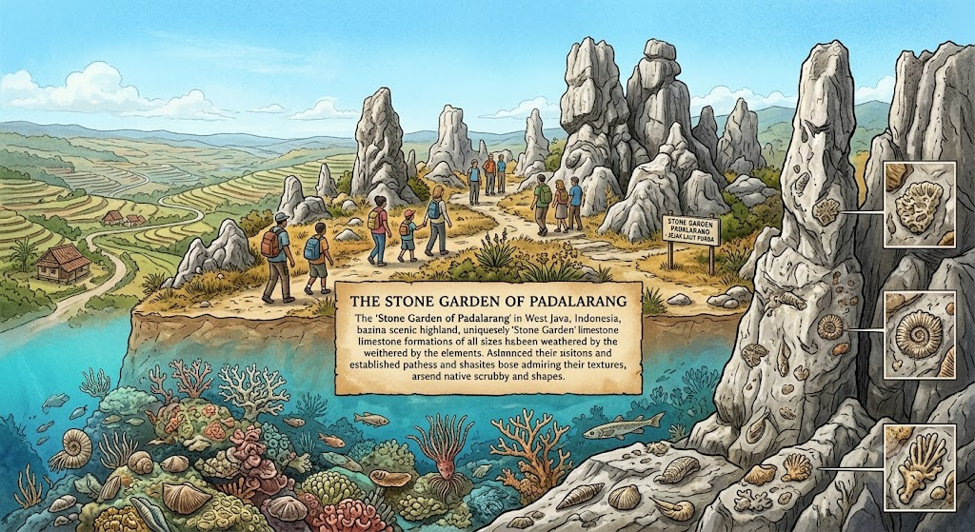

Perched high on a hilltop in West Java, the Stone Garden of Padalarang is a geological wonder that offers a glimpse into Earth's ancient past. Millions of years ago, this highland was not a mountain ridge, but a shallow seabed teeming with coral reefs. Over millennia, tectonic movements pushed the seabed upward, exposing the massive limestone formations to the elements. Today, visitors can walk among towering, uniquely shaped limestone rocks that still bear the fossilized remains of ancient marine organisms, surrounded by panoramic views of the surrounding valleys.

Question: According to the description of the Stone Garden of Padalarang, which statements are true? (Select two correct answers)
[ ] The current high-altitude landscape was once submerged under an ancient sea.
[ ] Geological forces and tectonic activity played a major role in elevating the site.
[ ] The unique rock formations are composed primarily of ancient volcanic basalt.
[ ] The site is restricted to geologists and closed to regular tourists.
[ ] Visitors are required to wear special gear due to extreme thermal activity.

Key Answers: A and B Explanation:
- A benar sesuai dengan kalimat "this highland was not a mountain ridge, but a shallow seabed."
- B benar sesuai dengan kalimat "tectonic movements pushed the seabed upward."
- C salah karena batuannya adalah batu kapur ("limestone"), bukan basal vulkanik ("volcanic basalt").
- D salah karena teks menyebutkan "visitors can walk among..." yang berarti tempat ini terbuka untuk umum.
- E salah karena tidak didukung oleh teks.

KARTU SOAL NOMOR 3

Mata Pelajaran : Bahasa Inggris
Fase/Kelas : F / XI
- Tujuan Pembelajaran: Peserta didik mampu menganalisis fitur arsitektural dan nilai historis candi dari teks deskriptif.
- Materi: Descriptive Text.
- Indikator Soal: Disajikan teks deskripsi candi bersejarah, peserta didik dapat mengidentifikasi ciri utama struktur bangunan tersebut.
- Level Kognitif: L2 (Aplikasi/Pemahaman Mendalam).
- Bentuk Soal: MCMA (Pilihan Ganda Kompleks / Checkbox).

The Majesty of Prambanan Temple

Prambanan is a towering masterpiece of Hindu temple architecture, built in the century in Central Java. The complex is characterized by its tall and pointed architecture, typical of Hindu temple design, with the towering central Shiva temple reaching an impressive height of $47$ meters. Inside the compound, the walls are adorned with intricate narrative bas-reliefs detailing the epic story of Ramayana. These reliefs are carved into the dark volcanic stone walls, showcasing remarkable precision and artistry that has survived centuries of volcanic eruptions and earthquakes.

Question: Based on the description of Prambanan Temple, which of the following assertions are correct? (Select two correct answers)
[ ] The structural design of Prambanan is marked by tall, pointed architectural features.
[ ] The inner stone walls display carvings depicting narratives from the Ramayana epic.
[ ]The entire temple complex is constructed using modern reinforced concrete materials.
[ ] The tallest temple spire within the complex is dedicated to the deity Vishnu.
[ ] The carvings have been completely erased due to frequent volcanic eruptions.

Key Answers: A and B Explanation:
- A benar sesuai teks ("characterized by its tall and pointed architecture").
- B benar sesuai teks ("bas-reliefs detailing the epic story of Ramayana").
- C salah karena candi ini dibuat dari batu vulkanik kuno, bukan beton modern.
- D salah karena candi tertinggi ditujukan untuk Dewa Siwa ("Shiva temple reaching... 47 meters"), bukan Wisnu.
- E salah karena bertentangan dengan teks.

KARTU SOAL NOMOR 4

Mata Pelajaran : Bahasa Inggris
Fase/Kelas : F / XI
- Tujuan Pembelajaran: Peserta didik mampu menganalisis interaksi komponen biotik-abiotik serta keunikan rantai makanan di ekosistem ekstrem berdasarkan teks deskriptif ilmiah populer.
- Materi: Descriptive Text.
- Indikator Soal: Disajikan teks deskripsi tentang sistem ventilasi hidrotermal laut dalam, peserta didik dapat menyimpulkan karakteristik adaptasi makhluk hidup dan sumber energi primer lingkungan ekstrem tersebut.
- Level Kognitif: L3 (Penalaran/Menganalisis).
- Bentuk Soal: MCMA (Pilihan Ganda Kompleks / Checkbox).

Oases of the Abyss
Deep beneath the ocean's surface, far beyond the reach of the sun's photic zone, lies a world of perpetual darkness and crushing hydrostatic pressure. Here, along tectonic plate boundaries, hydrothermal vents known as "black smokers" spew superheated, mineral-rich water reaching temperatures up to $400^\circ\text{C}$ into the near-freezing ambient sea. Under normal circumstances, this environment would be considered utterly uninhabitable. However, these deep-sea vents host one of the most unique and productive ecosystems on Earth, completely independent of solar energy.
The foundation of this bizarre biome is chemoautotrophic bacteria. Unlike terrestrial plants that rely on photosynthesis, these specialized microbes utilize chemosynthesis. They oxidize toxic hydrogen sulfide emitting from the vents, converting inorganic chemicals into organic matter that sustains a complex web of life. Surrounding the vents are massive colonies of giant tubeworms, blind shrimp, and predatory crabs. These organisms exhibit remarkable physiological adaptations; for instance, giant tubeworms lack a digestive tract entirely, relying instead on millions of symbiotic bacteria housed within their bodies to provide nutrition. In this extreme thermal gradient—where water can plunge from boiling to freezing in a matter of centimeters—life has established a highly specialized, localized paradise.

Question: According to the description of the hydrothermal vent ecosystems, which assertions are correct? (Select two correct answers)
[ ] Chemoautotrophs utilize local toxic compound emissions as a primary mechanism to generate metabolic energy.
[ ] Survival in the hydrothermal micro-environment requires specialized adaptations to withstand extreme thermal gradients.
[ ] The immense depth of hydrothermal vent sites ensures a complete absence of any complex multicellular predatory species.
[ ] The food web in deep-ocean benthic ecosystems depends heavily on falling organic debris from the sunlit ocean surface.
[ ] High hydrostatic pressure prevents any bacteria from surviving near black smokers.

Key Answers: A and B Explanation:
- A benar karena bakteri kemoautotrof memanfaatkan belerang (hidrogen sulfida) yang beracun untuk menghasilkan materi organik ("oxidize toxic hydrogen sulfide... converting inorganic chemicals into organic matter").
- B benar karena organisme di sana harus beradaptasi dengan perubahan suhu ekstrem antara air dingin laut dalam dan semburan air panas dari ventilasi ("extreme thermal gradient—where water can plunge from boiling to freezing...").
- C salah karena keberadaan kepiting pemangsa ("predatory crabs") membuktikan adanya spesies multiseluler karnivora.
- D salah karena ekosistem ini mandiri sepenuhnya dari energi matahari maupun sisa organik permukaan laut ("completely independent of solar energy").
- E salah karena bertentangan dengan teks.

KARTU SOAL NOMOR 17

Mata Pelajaran : Bahasa Inggris
Fase/Kelas : F / XI
- Tujuan Pembelajaran (TP): Peserta didik mampu menganalisis informasi rinci tersurat dan tersirat untuk menemukan bukti pendukung ide pokok dalam teks deskriptif berbahasa Inggris (descriptive text) dengan tepat.
- Materi Pokok: Descriptive Text (Place/Nature): Mengidentifikasi detail pendukung (supporting details) terkait pelestarian lingkungan (environmental protection) dan ekowisata.
- Level Kognitif: C4 (Menganalisis / Analyzing) – Peserta didik dituntut untuk memilah dan menentukan detail spesifik di dalam teks yang berfungsi sebagai bukti konkret untuk mendukung gagasan bahwa wilayah tersebut dilindungi secara lingkungan.
- Bentuk Soal: Pilihan Ganda Kompleks (Memilih 2 jawaban yang benar) / Multiple Choice Multiple Answer (MCMA).

Raja Ampat: A Hidden Paradise
Located in the western part of Papua, Indonesia, Raja Ampat is considered one of the world's richest marine ecosystems. The archipelago consists of more than 1,500 small islands, cays, and shoals. Its crystal-clear waters are home to over 1,500 species of fish and hundreds of coral species, making it a favorite destination for divers and marine researchers.
Apart from its underwater beauty, Raja Ampat offers breathtaking landscapes. Towering limestone cliffs rise above turquoise lagoons, while lush tropical forests cover many of the islands. Visitors often describe the scenery as untouched and peaceful because many areas remain protected from excessive tourism.
The local communities play an important role in preserving the environment. They cooperate with conservation organizations to maintain marine biodiversity and regulate fishing activities. Sustainable tourism has also become a major focus, encouraging visitors to respect local customs and minimize environmental impact.
Although reaching Raja Ampat requires considerable time and expense, many travelers believe the experience is worth every effort. They argue that the region's natural beauty and ecological significance make it one of Indonesia's greatest treasures.

Which two details support the idea that Raja Ampat is environmentally protected?(MCMA)
[ ] Local people cooperate with conservation groups.
[ ] Many visitors build new resorts every year.
[ ] Fishing activities are regulated.
[ ] The islands are crowded with tourists.
[ ] The forests are replaced with plantations.

Answer: A, C

- Presensi Kehadiran
PRESENSI KEHADIRAN MGMP BAHASA INGGRIS SMK ACEH TENGGARA

Nama | ETIQAH NUR
NIP | 198108312022212008
Asal Sekolah | SMK NEGERI 4 KUTACANE
Tanda Tangan | 
Added Time | 10-Sep-2026 09:53:33
Referrer Name
Task Owner | umarfruq.83@gmail.com

Nama | Raja Fauziah, S.Pd
NIP | 198801252023212022
Asal Sekolah | SMK Negeri 2 Kutacane
Tanda Tangan | 
Added Time | 10-Sep-2026 09:51:55
Referrer Name
Task Owner | umarfruq.83@gmail.com

Nama | Mira Wati
NIP | 199211062022212007
Asal Sekolah | SMKN 3 kutacane
Tanda Tangan | 
Added Time | 10-Sep-2026 09:51:52
Referrer Name
Task Owner | umarfruq.83@gmail.com

Nama | Umar Faruq
NIP | 198312222022211006
Asal Sekolah | SMKN DARUL HASANAH
Tanda Tangan | 
Added Time | 10-Sep-2026 12:56:39
Referrer Name
Task Owner | umarfruq.83@gmail.com

Nama | Novita Indah Sari
NIP | 198411212009042004
Asal Sekolah | SMKN 1 KUTACANE
Tanda Tangan | 
Added Time | 10-Sep-2026 12:42:32
Referrer Name
Task Owner | umarfruq.83@gmail.com

Nama | Selvianita Rahayu
NIP
Asal Sekolah | SMKS Anak Bangsa
Tanda Tangan | 
Added Time | 10-Sep-2026 10:56:17
Referrer Name
Task Owner | umarfruq.83@gmail.com

Nama | BUDIANTI AMRAN, S.Pd
NIP | 198708152022212005
Asal Sekolah | SMK PP NEGERI KUTACANE
Tanda Tangan | 
Added Time | 10-Sep-2026 10:51:33
Referrer Name
Task Owner | umarfruq.83@gmail.com

Nama | Suriani
NIP | 198608182009042008
Asal Sekolah | Smkn1 kutacane
Tanda Tangan | 
Added Time | 10-Sep-2026 10:22:51
Referrer Name
Task Owner | umarfruq.83@gmail.com

Nama | NURHAYATI, S.S
NIP | 197905242014032001
Asal Sekolah | SMKN 1 KUTACANE
Tanda Tangan | 
Added Time | 10-Sep-2026 10:06:44
Referrer Name
Task Owner | umarfruq.83@gmail.com

Nama | Fitri Erawati
NIP | 197909012011032001
Asal Sekolah | SMKN 2 KUTACANE
Tanda Tangan | 
Added Time | 10-Sep-2026 09:55:15
Referrer Name
Task Owner | umarfruq.83@gmail.com

Nama | Imron Rosyidi, S. Pd
NIP | 198312012009041003
Asal Sekolah | SMK Negeri 1 Kutacane
Tanda Tangan | 
Added Time | 10-Sep-2026 09:54:27
Referrer Name
Task Owner | umarfruq.83@gmail.com

Nama | ETIQAH NUR
NIP | 198108312022212008
Asal Sekolah | SMK NEGERI 4 KUTACANE
Tanda Tangan
Added Time | 10-Sep-2026 09:53:33
Referrer Name
Task Owner | umarfruq.83@gmail.com

Nama | Raja Fauziah, S.Pd
NIP | 198801252023212022
Asal Sekolah | SMK Negeri 2 Kutacane
Tanda Tangan
Added Time | 10-Sep-2026 09:51:55
Referrer Name
Task Owner | umarfruq.83@gmail.com

