SOAL TKA BAHASA INGGRIS SMK TP. 2026/2027
KARTU SOAL NOMOR 1

Mata Pelajaran : BAHASA INGGRIS
Fase/Kelas : F / XII

Elemen | Pemahaman Inferensial / Evaluasi dan Apresiasi
Subelemen | Sesuai indikator soal
Tujuan Pembelajaran | Peserta didik mampu menganalisis, mengevaluasi, atau menyimpulkan informasi berdasarkan teks.
Materi | NARRATIVE TEXT
Indikator Soal | Indikator: Memprediksi akhir cerita setelah membaca bagian awal teks naratif.
Level Kognitif | C4 – Menganalisis
Bentuk Soal | PG
Kunci Jawaban | B

The Unfinished Electrical Project
Raka and his classmates were working on a school project to build a simple automatic lighting system. Their teacher had given them three days to complete the project. On the first day, they prepared the materials and studied the circuit diagram.
On the second day, they started connecting the components. Raka was responsible for checking the wiring, while his friends installed the sensors and lamps.
Before going home, Raka noticed that one connection was different from the diagram. He told his friends that they should check it again before testing the circuit.
However, the group was tired and decided to continue the next morning. They carefully placed the equipment on the workbench and covered it before leaving the laboratory.
The next morning, they returned to the laboratory. Raka immediately took the diagram and compared it with the circuit. He discovered that one cable had been connected to the wrong terminal.

Question
What is the most likely next event in the story?
A. Raka and his friends will ignore the problem and present the project.
B. The students will correct the wiring before testing the circuit.
C. The students will throw away all the electrical components.
D. The teacher will cancel the entire project.
E. Raka will leave the laboratory without telling his friends.
Kunci Jawaban: B

Pembahasan
The students have identified an incorrect connection and are checking the diagram, so the most logical next step is to correct the wiring before testing.
KARTU SOAL NOMOR 2

Mata Pelajaran : BAHASA INGGRIS
Fase/Kelas : F / XII

Elemen | Pemahaman Inferensial / Evaluasi dan Apresiasi
Subelemen | Sesuai indikator soal
Tujuan Pembelajaran | Peserta didik mampu menganalisis, mengevaluasi, atau menyimpulkan informasi berdasarkan teks.
Materi | NARRATIVE TEXT
Indikator Soal | Indikator: Memprediksi akhir cerita setelah membaca bagian awal teks naratif.
Level Kognitif | C4 – Menganalisis
Bentuk Soal | PGK
Kunci Jawaban | A, C

The Broken Computer
Nina was preparing a presentation for her English class. She had spent several days creating slides about workplace communication. The presentation was scheduled for the following morning.
That evening, Nina opened the presentation file to make some final changes. Suddenly, her computer stopped responding. She tried to restart it, but the computer displayed an error message.
Nina became worried because the presentation file was stored on the computer. She remembered that she had previously saved another copy of the presentation on a flash drive, but she was not sure whether the latest version was there.
She immediately checked the flash drive. Fortunately, the file was available, although it did not contain the changes she had made that evening.
Nina then decided to review the presentation again. She used another computer at home and began updating the slides using the backup file.

Question
Which TWO events are most likely to happen next?
A. Nina will probably complete the presentation using the backup file.
B. Nina will probably abandon the presentation completely.
C. Nina may ask a teacher or technician for help with the broken computer later.
D. Nina will delete the backup file.
E. Nina will stop attending her English class.
Kunci Jawaban: A, C

Pembahasan
Nina has a backup file and has already begun updating it on another computer. It is also reasonable that she may seek help for the broken computer later.

KARTU SOAL NOMOR 3

Mata Pelajaran : BAHASA INGGRIS
Fase/Kelas : F / XII

Elemen | Pemahaman Inferensial / Evaluasi dan Apresiasi
Subelemen | Sesuai indikator soal
Tujuan Pembelajaran | Peserta didik mampu menganalisis, mengevaluasi, atau menyimpulkan informasi berdasarkan teks.
Materi | DESCRIPTIVE TEXT
Indikator Soal | Indikator: Menentukan fakta tambahan agar descriptive text lebih informatif/menarik/persuasif.
Level Kognitif | C5 – Mengevaluasi
Bentuk Soal | PGK
Kunci Jawaban | A, C

The School Workshop
The mechanical workshop at the vocational school is a large room used by students for practical learning. Several workstations are arranged around the room. Each workstation has basic tools and equipment used for motorcycle maintenance.
The workshop has good ventilation and sufficient lighting. Safety signs are placed on several walls to remind students about proper working procedures.
Students usually work in small groups. They learn how to inspect motorcycle components, identify simple problems, and perform basic maintenance under the teacher's supervision.
The workshop is cleaned regularly. Tools are returned to their storage areas after every practical lesson.

Question
The school wants to make the description more informative and attractive for prospective students. Which TWO additional facts would be most appropriate?
A. The workshop has a safety equipment station containing helmets, gloves, and safety glasses.
B. The school was established many years ago.
C. The workshop has several diagnostic tools that students can use during practical training.
D. Some students like playing football after school.
E. The school canteen sells various kinds of food.
Kunci Jawaban: A, C

Pembahasan
Both facts directly describe workshop facilities and strengthen the description for prospective vocational students.
KARTU SOAL NOMOR 4

Mata Pelajaran : BAHASA INGGRIS
Fase/Kelas : F / XII

Elemen | Pemahaman Inferensial / Evaluasi dan Apresiasi
Subelemen | Sesuai indikator soal
Tujuan Pembelajaran | Peserta didik mampu menganalisis, mengevaluasi, atau menyimpulkan informasi berdasarkan teks.
Materi | ANALYTICAL EXPOSITION
Indikator Soal | Indikator: Menentukan fakta tambahan agar analytical exposition lebih informatif/persuasif.
Level Kognitif | C5 – Mengevaluasi
Bentuk Soal | PG
Kunci Jawaban | C

Students Should Learn Basic Digital Safety
Digital technology has become an important part of students' lives. Students use computers and smartphones for learning, communication, and entertainment. Therefore, schools should teach students basic digital safety.
Students need to understand how to create strong passwords and protect personal information. They should also know that not every message or website is trustworthy.
Another important skill is recognizing suspicious links and messages. Students who understand these risks can make safer decisions when using the internet.
Digital safety education can also teach students to behave responsibly online. They should understand that their online actions can affect other people.

Question
Which additional fact would best strengthen the writer's argument?
A. Many students enjoy watching movies online.
B. Students spend time using digital devices for entertainment.
C. Students may encounter phishing messages or suspicious links while using online services.
D. Some students prefer printed textbooks.
E. Smartphones are available in many different colors.
Kunci Jawaban: C

Pembahasan
Option C directly provides a real risk that supports the argument that students need digital safety education.

KARTU SOAL NOMOR 5

Mata Pelajaran : BAHASA INGGRIS
Fase/Kelas : F / XII

Elemen | Pemahaman Inferensial / Evaluasi dan Apresiasi
Subelemen | Sesuai indikator soal
Tujuan Pembelajaran | Peserta didik mampu menganalisis, mengevaluasi, atau menyimpulkan informasi berdasarkan teks.
Materi | NARRATIVE TEXT
Indikator Soal | Indikator: Menentukan bagian teks yang menggambarkan karakter utama.
Level Kognitif | C4 – Menganalisis
Bentuk Soal | PG
Kunci Jawaban | A

Arif and the Difficult Assignment
Arif was a student who often helped his classmates during practical lessons. One afternoon, his group received a difficult assignment to assemble a simple control panel.
At first, several students were confused about the wiring diagram. Arif carefully studied the diagram and explained the basic connections to his friends.
During the activity, the group discovered that one component was missing. Instead of blaming another student, Arif checked the equipment list and informed the teacher about the problem.
The teacher gave them a replacement component. Arif then helped the group continue the work.
Although the assignment took longer than expected, Arif remained patient. He encouraged his friends to check each connection carefully before testing the panel.

Question
Which sentence best represents Arif's character?
A. “Arif carefully studied the diagram and explained the basic connections to his friends.”
B. “The assignment took longer than expected.”
C. “The teacher gave them a replacement component.”
D. “The group received a difficult assignment.”
E. “The students discovered that one component was missing.”
Kunci Jawaban: A

Pembahasan
Option A directly shows that Arif is knowledgeable and helpful to his classmates.

KARTU SOAL NOMOR 6

Mata Pelajaran : BAHASA INGGRIS
Fase/Kelas : F / XII

Elemen | Pemahaman Inferensial / Evaluasi dan Apresiasi
Subelemen | Sesuai indikator soal
Tujuan Pembelajaran | Peserta didik mampu menganalisis, mengevaluasi, atau menyimpulkan informasi berdasarkan teks.
Materi | DESCRIPTIVE TEXT
Indikator Soal | Indikator: Mengevaluasi aspek utama/aspek lain dalam descriptive text.
Level Kognitif | C5 – Mengevaluasi
Bentuk Soal | PGK
Kunci Jawaban | A, B

The New Technology Laboratory
The technology laboratory is one of the newest facilities at the vocational school. It contains computers, networking equipment, electronic components, and several workstations.
The room is spacious and well organized. Each workstation has enough space for students to work comfortably. The computers are connected to a local network so students can practice basic networking activities.
One side of the laboratory contains electronic components. Students can use these components to learn about simple circuits and electronic systems.
The laboratory also has a projector and a large display. Teachers can use these facilities to demonstrate software or explain technical procedures.
Safety instructions are displayed near the entrance. Students must follow the instructions before using the equipment.

Question
Which TWO aspects make the laboratory particularly suitable for vocational learning?
A. It provides equipment related to technical practice.
B. It has facilities that support teacher demonstrations.
C. It has a large number of decorative plants.
D. It is located near the school canteen.
E. It has colorful walls.
Kunci Jawaban: A, B

Pembahasan
Technical equipment supports practical learning, while the projector and display support demonstrations of technical procedures.

KARTU SOAL NOMOR 7

Mata Pelajaran : BAHASA INGGRIS
Fase/Kelas : F / XII

Elemen | Pemahaman Inferensial / Evaluasi dan Apresiasi
Subelemen | Sesuai indikator soal
Tujuan Pembelajaran | Peserta didik mampu menganalisis, mengevaluasi, atau menyimpulkan informasi berdasarkan teks.
Materi | NARRATIVE TEXT
Indikator Soal | Indikator: Menentukan bagian teks yang menggambarkan karakter utama.
Level Kognitif | C5 – Mengevaluasi
Bentuk Soal | PGK
Kunci Jawaban | A, C

Sinta's First Presentation
Sinta was nervous when her teacher asked her to present a project about renewable energy. She had never spoken in front of the whole class before.
The night before the presentation, Sinta practiced several times. She prepared simple notes and checked the information carefully.
When she stood in front of the class, her hands were slightly shaking. She took a deep breath and began explaining the project.
During the presentation, one student asked a question that Sinta had not expected. She did not immediately know the answer. Instead of making up an answer, she honestly said that she needed to check the information.
After the presentation, Sinta thanked her classmates for listening. Her teacher praised her because she had prepared carefully and responded honestly when she did not know something.

Question
Which TWO actions best show Sinta's positive character?
A. She practiced several times before the presentation.
B. She avoided answering the unexpected question.
C. She admitted that she needed to check the information.
D. She refused to present the project.
E. She ignored her teacher's feedback.
Kunci Jawaban: A, C

Pembahasan
Practicing shows preparation and admitting that she needed to check the information shows honesty.

KARTU SOAL NOMOR 8

Mata Pelajaran : BAHASA INGGRIS
Fase/Kelas : F / XII

Elemen | Pemahaman Inferensial / Evaluasi dan Apresiasi
Subelemen | Sesuai indikator soal
Tujuan Pembelajaran | Peserta didik mampu menganalisis, mengevaluasi, atau menyimpulkan informasi berdasarkan teks.
Materi | PROCEDURE TEXT
Indikator Soal | Indikator: Menentukan bagian teks yang dapat diaplikasikan dalam kehidupan nyata.
Level Kognitif | C5 – Mengevaluasi
Bentuk Soal | PG
Kunci Jawaban | B

How to Prepare for a Practical Examination
Before a practical examination, students should read the instructions carefully. They need to understand what task they must complete and what equipment they are allowed to use.
Students should prepare their tools before the examination begins. They should check whether the tools are complete and in good condition.
During the examination, students should follow the procedure step by step. They should not skip important safety instructions simply because they want to finish quickly.
Students should also check their work before submitting it. If they find an error, they should correct it when possible.
After completing the examination, students should clean the work area and return the tools to their proper places.
These habits can also be useful outside school, especially when students work in real workplaces where safety, accuracy, and responsibility are important.

Question
Which action from the text is most applicable to a real workplace situation?
A. Ignoring instructions when a task seems easy.
B. Checking tools before using them and following safety procedures.
C. Finishing work quickly without checking the result.
D. Leaving tools on the workbench after completing a task.
E. Using equipment without knowing its function.
Kunci Jawaban: B

Pembahasan
Checking tools and following safety procedures are directly applicable to real workplace practice.
KARTU SOAL NOMOR 9

Mata Pelajaran : BAHASA INGGRIS
Fase/Kelas : F / XII

Elemen | Pemahaman Inferensial / Evaluasi dan Apresiasi
Subelemen | Sesuai indikator soal
Tujuan Pembelajaran | Peserta didik mampu menganalisis, mengevaluasi, atau menyimpulkan informasi berdasarkan teks.
Materi | ANALYTICAL EXPOSITION
Indikator Soal | Indikator: Menilai fakta/opini dalam analytical exposition text.
Level Kognitif | C5 – Mengevaluasi
Bentuk Soal | PGK
Kunci Jawaban | A, C

Schools Should Encourage Students to Read More
Reading is an important activity for students because it can help them develop knowledge and language skills. Schools should therefore encourage students to read regularly.
Students can read textbooks, newspapers, magazines, novels, and digital articles. Different types of reading materials can expose students to new information and vocabulary.
Reading may also help students understand different perspectives. When students read about other people's experiences or ideas, they can develop a broader understanding of the world.
Schools can encourage reading by providing comfortable libraries and allowing students to choose materials that match their interests. Teachers can also recommend books and discuss them in class.
However, some students may find it difficult to develop a reading habit because they spend much of their free time using digital entertainment. Schools and families can help by creating regular reading routines.

Question
Which TWO statements are opinions rather than directly verifiable facts in the text?
A. “Schools should encourage students to read regularly.”
B. “Students can read textbooks, newspapers, magazines, novels, and digital articles.”
C. “Reading may also help students understand different perspectives.”
D. “Schools can provide libraries.”
E. “Students spend much of their free time using digital entertainment.”
Kunci Jawaban: A, C

Pembahasan
Option A is a recommendation, while C is a claim about an effect that would require evidence to establish as a fact.

KARTU SOAL NOMOR 10

Mata Pelajaran : BAHASA INGGRIS
Fase/Kelas : F / XII

Komponen | Keterangan
Elemen | Pemahaman Tekstual
Subelemen | Menemukan/Mengidentifikasi Informasi
Tujuan Pembelajaran | Peserta didik mampu memahami dan menyusun kembali informasi eksplisit dalam narrative text.
Materi | Narrative Text
Indikator Soal | Peserta didik mampu menyusun poin-poin utama dari narrative text dengan konteks kehidupan sehari-hari/vokasional.
Level Kognitif | C4 – Menganalisis
Bentuk Soal | Pilihan Ganda
Kunci | B

The Broken Bicycle
Last Saturday morning, Raka planned to ride his bicycle to his uncle's workshop. He wanted to learn how to repair a bicycle because he was interested in mechanical work. His bicycle had been working well for several months, so he did not expect to have any problems during the trip.
After riding for about twenty minutes, Raka heard an unusual sound from the back wheel. He stopped and checked the bicycle. He discovered that the chain had come off the gear. Raka tried to put the chain back by himself, but he did not know how to position it correctly. His hands became dirty, and he began to feel frustrated.
While Raka was trying to fix the problem, an elderly man named Mr. Hasan passed by. He noticed that Raka was having difficulty. Mr. Hasan stopped and asked whether he needed help. Raka explained what had happened. Mr. Hasan smiled and showed him how to place the chain back onto the gear. He also explained that Raka should check the condition of the chain regularly and keep it clean.
After the bicycle was repaired, Raka thanked Mr. Hasan. He continued his journey to his uncle's workshop. When he arrived, he told his uncle about the incident. His uncle was pleased because Raka had not only solved his problem but had also learned something useful from another person.
At the workshop, Raka learned how to inspect bicycle brakes, adjust the seat, clean the chain, and check the tires. His uncle explained that basic maintenance could prevent many problems. Raka realized that repairing something was not only about fixing it after it was broken. Regular maintenance was equally important.
Before going home, Raka wrote several notes about what he had learned. He planned to check his bicycle every weekend. He also decided that whenever he learned something useful, he would share the knowledge with his friends.

Question
Which sequence best represents the main points of the story?
- Raka bought a new bicycle → he went to the workshop → his uncle repaired the bicycle → Raka went home.
- Raka rode to his uncle's workshop → his bicycle developed a chain problem → Mr. Hasan helped him → Raka learned about bicycle maintenance.
- Raka went to school → his bicycle was stolen → Mr. Hasan found it → Raka repaired it at school.
- Raka repaired a motorcycle → he met his uncle → his bicycle broke down → he learned how to ride safely.
- Raka visited Mr. Hasan → he bought bicycle equipment → his uncle taught him mechanical skills → he sold his bicycle.
Kunci Jawaban: B

Pembahasan
Pilihan B paling tepat karena memuat rangkaian peristiwa utama secara berurutan: Raka berangkat ke bengkel, mengalami masalah pada rantai sepeda, mendapat bantuan Mr. Hasan, kemudian belajar pentingnya perawatan sepeda di bengkel pamannya.

KARTU SOAL NOMOR 11

Mata Pelajaran : BAHASA INGGRIS
Fase/Kelas : F / XII

Komponen | Keterangan

Elemen | Pemahaman Tekstual

Subelemen | Menemukan/Mengidentifikasi Informasi

Tujuan Pembelajaran | Peserta didik mampu menemukan informasi eksplisit dalam procedure text dan mengidentifikasi langkah-langkah penting.

Materi | Procedure Text – Computer Software Installation

Indikator Soal | Peserta didik mampu mengidentifikasi informasi penting dalam procedure text dengan konteks vokasional.

Level Kognitif | C3 – Menerapkan

Bentuk Soal | Pilihan Ganda Kompleks

Kunci | A, C, E

How to Prepare a Computer Before Installing New Software
Installing new software on a computer may look simple, but proper preparation is important. A computer should be checked before new software is installed because the installation process can sometimes cause problems when the device does not meet the software requirements.
First, save important files to another storage location. Users can copy documents, photographs, videos, or other important files to an external drive or a trusted cloud storage service. This step is important because some installation problems may cause files to become inaccessible.
Second, check the computer's available storage space. Open the storage settings and determine how much free space remains. If the computer does not have enough space, remove unnecessary temporary files or transfer large files to another storage device.
Third, check the software requirements. Read the information provided by the software developer. Pay attention to the operating system, processor, memory, and storage requirements. If the computer does not meet the minimum requirements, the software may not work properly.
Next, make sure the computer has a stable power supply. If the installation is performed on a laptop, charge the battery or connect the charger. If the computer suddenly turns off during installation, the process may fail.
After that, close unnecessary programs. Applications running in the background may use computer memory and processing power. Closing them can help the installation process run more smoothly.
Finally, download the software from a trusted source. Avoid unknown websites because some files may contain harmful programs. After downloading the installer, follow the instructions displayed on the screen and wait until the installation is completely finished.
After the installation, restart the computer if the software requests it. Then open the program and check whether it works correctly. If the software runs normally, the installation has been completed successfully.
Following these steps can reduce the possibility of problems during software installation. More importantly, users learn to prepare their computers carefully instead of immediately installing programs without checking the device's condition.

Question
Which THREE statements are explicitly mentioned in the procedure?
- Users should back up important files before installation.
- Users should remove every file from the computer.
- Users should check the software requirements before installation.
- Users should download software only from unknown websites.
- Users should ensure that the computer has sufficient power during installation.
Kunci Jawaban: A, C, E

Pembahasan
A benar, karena teks menyatakan bahwa pengguna harus menyimpan atau mencadangkan file penting.
C benar, karena pengguna harus memeriksa persyaratan software.
E benar, karena komputer harus memiliki sumber daya listrik yang cukup.
B salah, karena hanya file yang tidak diperlukan yang dapat dihapus.
D salah, karena teks justru menyarankan mengunduh software dari sumber terpercaya.

KARTU SOAL NOMOR 12

Mata Pelajaran : BAHASA INGGRIS
Fase/Kelas : F / XII

Komponen | Keterangan
Elemen | Pemahaman Tekstual
Subelemen | Menemukan/Mengidentifikasi Informasi
Tujuan Pembelajaran | Peserta didik mampu mengidentifikasi informasi eksplisit dalam descriptive text.
Materi | Descriptive Text – Vocational Workshop
Indikator Soal | Peserta didik mampu mengidentifikasi informasi penting yang disebutkan secara eksplisit dalam descriptive text dengan konteks vokasional.
Level Kognitif | C2 – Memahami
Bentuk Soal | Pilihan Ganda
Kunci | C

The Electrical Installation Workshop
The electrical installation workshop at a vocational school is a special room where students learn practical electrical skills. The room is designed to support both theoretical learning and hands-on activities. Students usually spend several hours in the workshop each week to practice the skills they have learned in class.
The workshop is located on the first floor of the school building. It has several large windows, so natural light can enter the room during the day. The room also has good ventilation. Several ceiling fans help maintain comfortable air circulation when students are working.
There are six large workbenches in the center of the workshop. Each workbench has electrical training equipment that students can use for practical activities. The equipment includes switches, sockets, cables, lamps, circuit breakers, measuring instruments, and training panels.
The workshop also has a storage room at the back. Tools that are not being used are stored there. The tools include screwdrivers, pliers, cable cutters, measuring tapes, and several other hand tools. Each tool has a specific place, so students are expected to return tools after using them.
Safety is an important part of the workshop. Safety signs are placed on several walls. One sign reminds students to wear appropriate protective equipment. Another sign reminds them to turn off the power before working on an electrical circuit.
There is also a teacher's desk near the entrance. From the desk, the teacher can observe students while they are working. A first-aid kit is placed in a visible location near the teacher's desk. A fire extinguisher is also available in case of an emergency.
The workshop is not only a place for students to practice electrical installation. It also teaches them to work carefully, follow procedures, maintain equipment, and cooperate with other students. These habits are important because electrical work requires responsibility and attention to safety.

Question
Which statement is explicitly stated in the text?
A. The workshop has eight workbenches.
B. The storage room is located near the main entrance.
C. The workshop contains electrical training equipment.
D. Students are prohibited from using measuring instruments.
E. The workshop does not have safety equipment.
Kunci Jawaban: C

Pembahasan
Jawaban C disebutkan secara langsung dalam teks. Pada paragraf ketiga dijelaskan bahwa setiap workbench memiliki electrical training equipment, termasuk switches, sockets, cables, lamps, circuit breakers, measuring instruments, dan training panels.
KARTU SOAL NOMOR 13

Mata Pelajaran : BAHASA INGGRIS
Fase/Kelas : F / XII

Komponen | Keterangan
Elemen | Pemahaman Tekstual
Subelemen | Menemukan/Mengidentifikasi Informasi
Tujuan Pembelajaran | Peserta didik mampu menyusun kembali poin-poin utama dari narrative text berdasarkan informasi eksplisit.
Materi | Narrative Text – School Project
Indikator Soal | Peserta didik mampu menyusun poin-poin utama dari narrative text dengan konteks kehidupan akademik dasar.
Level Kognitif | C4 – Menganalisis
Bentuk Soal | Pilihan Ganda Kompleks
Kunci | A, B, D

A Lesson from the School Project
At the beginning of the semester, Ms. Anita asked her students to work in groups and create a simple project related to environmental problems. Each group had to identify a problem around the school and propose a practical solution. The students were allowed to choose their own topics.
One group consisting of Fajar, Nisa, Dimas, and Sari decided to focus on plastic waste. They noticed that many students bought drinks in plastic bottles during break time. Some students put the empty bottles in ordinary trash bins, while others left them on tables or near the school yard.
The group discussed several possible solutions. Fajar suggested putting more trash bins around the school. Nisa thought that the school should encourage students to use reusable bottles. Dimas suggested creating posters about plastic waste. Sari proposed combining all three ideas.
After discussing the suggestions, the group decided to create a small campaign. They designed posters, prepared a short presentation, and placed information cards near the school canteen. They also talked to the canteen staff about reducing the use of single-use plastic.
During the project, the students faced several difficulties. Their first poster design was too complicated, so other students found it difficult to understand. They discussed the problem and decided to simplify the design. They used short sentences, clear pictures, and larger letters.
Another problem occurred when the group had to present their project. Dimas was nervous because he rarely spoke in front of many people. The other members encouraged him and helped him practice. On presentation day, Dimas successfully explained the problem and their proposed solutions.
After the presentation, several teachers gave positive feedback. They said that the project was simple but practical. Some students also started bringing reusable bottles to school. The group realized that their project did not need to be perfect to create a positive change.
At the end of the semester, Ms. Anita asked each group to reflect on the project. Fajar said that he had learned how important teamwork was. Nisa learned that a good idea needed to be communicated clearly. Dimas became more confident speaking in public, while Sari learned that problems could be solved more easily when people listened to different opinions.
The students understood that the most important result was not the grade they received. The project taught them how to identify a real problem, work together, communicate ideas, overcome difficulties, and create a practical solution.

Question
Which THREE points represent the main events of the narrative?
A. The students identified plastic waste as a problem around the school.
B. The group created a campaign and presented solutions to reduce plastic waste.
C. The students decided that environmental problems were impossible to solve.
D. The group faced difficulties but improved their project through teamwork.
E. Ms. Anita canceled the project because the students could not work together.
Kunci Jawaban: A, B, D

Pembahasan
Jawaban A, B, dan D merupakan poin-poin utama yang secara langsung membentuk alur cerita.
- A → kelompok mengidentifikasi masalah sampah plastik.
- B → kelompok membuat kampanye dan mempresentasikan solusi.
- D → kelompok mengalami kesulitan dan menyelesaikannya melalui kerja sama.
Pilihan C dan E tidak sesuai dengan isi cerita.

KARTU SOAL NOMOR 14

Mata Pelajaran : BAHASA INGGRIS
Fase/Kelas : F / XII
Komponen | Keterangan
Elemen | Pemahaman Tekstual
Subelemen | Membuat kerangka
Tujuan Pembelajaran | Peserta didik mampu menyimpulkan pesan moral dari narrative text berdasarkan rangkaian peristiwa dalam teks.
Materi | Narrative Text – Moral Message
Indikator Soal | Peserta didik mampu menyimpulkan pesan moral narrative text dengan konteks vokasional.
Level Kognitif | C4 – Menganalisis
Bentuk Soal | Pilihan Ganda
Kunci Jawaban | C

The Small Workshop and the Big Problem
Rafi was a vocational school student who enjoyed working with machines. He often spent his free time in his uncle's small motorcycle workshop. Although the workshop was not large, it had several useful tools and a simple work area where customers could bring their motorcycles for maintenance.
One afternoon, Rafi's uncle asked him to organize some tools because several tools had been placed randomly on the workbench. Rafi agreed to do the task. He collected screwdrivers, wrenches, pliers, and other tools and put them into different boxes. However, he did not check whether all the tools were still in good condition.
The next morning, a customer brought a motorcycle because its brakes were making an unusual sound. Rafi's uncle asked Rafi to prepare the tools. Rafi quickly took a wrench from one of the boxes. Unfortunately, the wrench was damaged. Its handle was loose, but Rafi did not notice it.
While his uncle was preparing to inspect the motorcycle, Rafi gave him the damaged wrench. When his uncle saw it, he immediately stopped and checked the tool. He explained that using damaged tools could make the work unsafe and could damage the motorcycle.
Rafi felt embarrassed because he had organized the tools without checking their condition. He apologized to his uncle. Instead of becoming angry, his uncle asked Rafi to inspect every tool in the workshop.
Rafi spent the rest of the morning checking the equipment. He found several tools that were damaged or needed maintenance. He separated them from the usable tools and made a list of the equipment that needed to be repaired or replaced.
After completing the task, Rafi realized that organizing something was not simply about putting objects in the correct places. It was also important to check their condition and make sure they were safe to use.
Several weeks later, the workshop became more organized. Every tool had a specific place, and damaged equipment was clearly labeled. Rafi also created a simple checklist for checking tools before they were used.
His uncle was pleased with the improvement. He told Rafi that a good technician should not only know how to repair machines but should also understand safety, responsibility, and careful preparation.
Rafi remembered his mistake and promised himself that he would never ignore the condition of tools again. He also realized that mistakes could become valuable lessons when people were willing to admit them and improve their behavior.

Question
What is the most appropriate moral message of the story?
A. A technician should always work as quickly as possible.
B. Organizing tools is more important than checking their condition.
C. People should learn from their mistakes and take responsibility for their work.
D. Damaged tools should always be thrown away immediately.
E. Students should never work in a motorcycle workshop.
Answer: C

Pembahasan
Pesan moral utama cerita adalah bahwa seseorang perlu bertanggung jawab terhadap pekerjaannya dan belajar dari kesalahan. Rafi awalnya hanya mengatur alat tanpa memeriksa kondisinya. Setelah menyadari kesalahannya, ia melakukan pemeriksaan, membuat daftar, dan memperbaiki sistem penyimpanan alat.
KARTU SOAL NOMOR 15

Mata Pelajaran : BAHASA INGGRIS
Fase/Kelas : F / XII

Komponen | Keterangan
Elemen | Pemahaman Tekstual
Subelemen | Membuat kerangka
Tujuan Pembelajaran | Peserta didik mampu menyusun informasi utama procedure text dalam bentuk kerangka atau daftar.
Materi | Procedure Text – Electrical Installation
Indikator Soal | Peserta didik mampu menyusun poin utama menjadi kerangka/daftar procedure text dalam konteks vokasional.
Level Kognitif | C4 – Menganalisis
Bentuk Soal | Pilihan Ganda Kompleks
Kunci Jawaban | A, C, E

How to Prepare a Simple Electrical Installation Practice
Before students begin an electrical installation practice, they need to prepare the work area, equipment, and safety equipment. Proper preparation is important because electrical work can be dangerous when students ignore safety procedures.
First, students should clean and organize the work area. The floor must be dry, and unnecessary objects should be removed. Students should make sure that they have enough space to move safely while working.
Second, students need to prepare the necessary tools. These may include screwdrivers, pliers, cable cutters, measuring tape, a voltage tester, and other appropriate tools. Before using them, students should check whether the tools are in good condition.
Third, students should prepare the electrical components required for the practice. Depending on the project, these components may include cables, switches, sockets, lamps, circuit breakers, and electrical boxes. Students should check the components against the project plan so that no important items are missing.
The next step is to prepare personal protective equipment. Students should wear appropriate clothing and safety equipment. They should also remove accessories that could interfere with their work.
After all the equipment is ready, students should study the installation diagram. They need to understand where each component will be installed and how the components are connected. If there is anything they do not understand, they should ask the teacher before starting.
Before connecting any electrical circuit, students must make sure that the power source is turned off. They should use appropriate testing equipment to confirm that the circuit is not energized.
Students can then begin the installation according to the diagram. They should work carefully and avoid making unnecessary changes to the design. Each connection should be checked before moving to the next step.
After completing the installation, students should inspect the circuit again. They should check the position of the components, the condition of the cables, and the connections. The teacher should inspect the installation before the circuit is energized.
Finally, the work area should be cleaned. Tools must be returned to their proper places, unused materials should be stored correctly, and waste materials should be disposed of safely.
Following these steps helps students develop technical skills as well as good working habits. They learn that successful electrical work requires preparation, accuracy, safety, and responsibility.

Question
Which THREE sequences correctly represent the main stages of the procedure?
A. Prepare the work area → prepare tools → prepare components → check the diagram.
B. Ignore safety equipment → connect the power → install components → check the circuit.
C. Prepare protective equipment → study the installation diagram → turn off the power → begin installation.
D. Install the circuit → choose the diagram → prepare tools → clean the work area.
E. Inspect the completed installation → clean the work area → return tools to their places.
Correct Answers: A, C, E

Pembahasan
- A benar karena merupakan rangkaian awal prosedur.
- C benar karena menunjukkan tahapan persiapan sebelum instalasi.
- E benar karena merupakan tahapan akhir setelah instalasi selesai.
- B salah karena mengabaikan keselamatan.
- D salah karena urutan langkahnya tidak sesuai dengan prosedur.

KARTU SOAL NOMOR 16

Mata Pelajaran : BAHASA INGGRIS
Fase/Kelas : F / XII

Komponen | Keterangan
Elemen | Pemahaman Tekstual
Subelemen | Membuat kerangka
Tujuan Pembelajaran | Peserta didik mampu mengevaluasi rangkaian peristiwa dan menyimpulkan pesan moral narrative text.
Materi | Narrative Text – Moral Values
Indikator Soal | Peserta didik mampu menyimpulkan pesan moral narrative text dengan konteks vokasional/akademik dasar.
Level Kognitif | C5 – Mengevaluasi
Bentuk Soal | Pilihan Ganda Kompleks
Kunci Jawaban | B, C, D

The Student Who Wanted to Finish First
Doni was known as one of the fastest students in his vocational class. Whenever the teacher gave the students a practical assignment, Doni usually finished before everyone else. He was proud of his ability to work quickly, and he often believed that finishing first meant doing the best work.
One day, the students received an assignment to assemble a simple electrical circuit. The teacher gave them a diagram and explained that every connection had to be checked carefully before the circuit was tested.
Doni immediately collected the components and began working. He connected the cables quickly and assembled the switches and lamps. His classmates were still studying the diagram when Doni announced that his circuit was finished.
The teacher came to inspect his work. He noticed that one cable had been connected to the wrong terminal. The teacher asked Doni to check the diagram again. Doni looked at the circuit and realized that he had missed an important detail.
Doni corrected the connection. However, when he tested the circuit, the lamp did not turn on. He became confused and checked the connections again. This time, he discovered that another cable had been connected incorrectly.
Meanwhile, several classmates who had worked more slowly had already completed their circuits successfully. They had checked each connection carefully before testing their work.
Doni felt disappointed. He had spent extra time correcting his mistakes, even though he had initially wanted to finish first.
The teacher did not criticize him. Instead, she explained that practical work was not a race. A good technician needed to be accurate, patient, and responsible. Working quickly could be useful, but speed was not valuable if it caused repeated mistakes.
After the lesson, Doni thought about his behavior. He realized that he had been more interested in finishing before his classmates than in producing good work.
The following week, the students received another practical assignment. This time, Doni studied the diagram carefully before touching the equipment. He prepared the components, checked the tools, and connected each cable according to the diagram.
He finished later than some of his classmates, but his circuit worked correctly on the first test.
Doni was happy with the result. He learned that working carefully did not mean working slowly without purpose. Instead, careful preparation could actually save time because it reduced mistakes.
From that day forward, Doni changed his approach to practical assignments. He still worked efficiently, but he no longer tried to finish simply to be the first person in the class.
He began to understand that success was not measured by how quickly a task was completed. It was measured by the quality of the result, the accuracy of the process, and the responsibility shown while doing the work.

Question
Which THREE statements best express the moral lessons that can be learned from the story?
A. Working quickly is always more important than working accurately.
B. Good results require accuracy and careful preparation.
C. People should not measure success only by being the first to finish.
D. Mistakes can become useful lessons when people reflect and improve.
E. Students should avoid practical assignments if they are difficult.
Correct Answers: B, C, D

Pembahasan
B, C, dan D merupakan pesan moral yang didukung oleh keseluruhan cerita.
- B benar: Doni belajar bahwa ketelitian dan persiapan menghasilkan pekerjaan yang lebih baik.
- C benar: Cerita menunjukkan bahwa menjadi orang pertama yang selesai bukan ukuran utama keberhasilan.
- D benar: Doni melakukan kesalahan, merefleksikannya, lalu memperbaiki cara kerjanya.
- A salah: Cerita justru menunjukkan bahwa kecepatan tanpa ketelitian dapat menimbulkan kesalahan.
- E salah: Kesulitan bukan alasan untuk menghindari tugas praktik.

KARTU SOAL NOMOR 17

Mata Pelajaran : Bahasa Inggris
Fase/Kelas : F / XII

Tujuan Pembelajaran | : | Peserta didik mampu menyimpilkan topik, ide pokok/ gagasan utama, makna, target pembaca pesan moral yang tidak secara eksplisit dinyatakan dalam teks.
Materi | : | Descriptive Text – Main Idea, Topic, Inference, Meaning, Target Reader, and Moral Message
Indikator Soal | : | Menyimpulkan topik descriptive text yang menggunakan struktur kalimat sederhana dan beberapa kalimat majemuk dasar dengan konteks sehari-hari/ vokasional.
Level Kognitif  Bentuk Soal | :  : | C4 (Menganalisis)  Pilihan Ganda

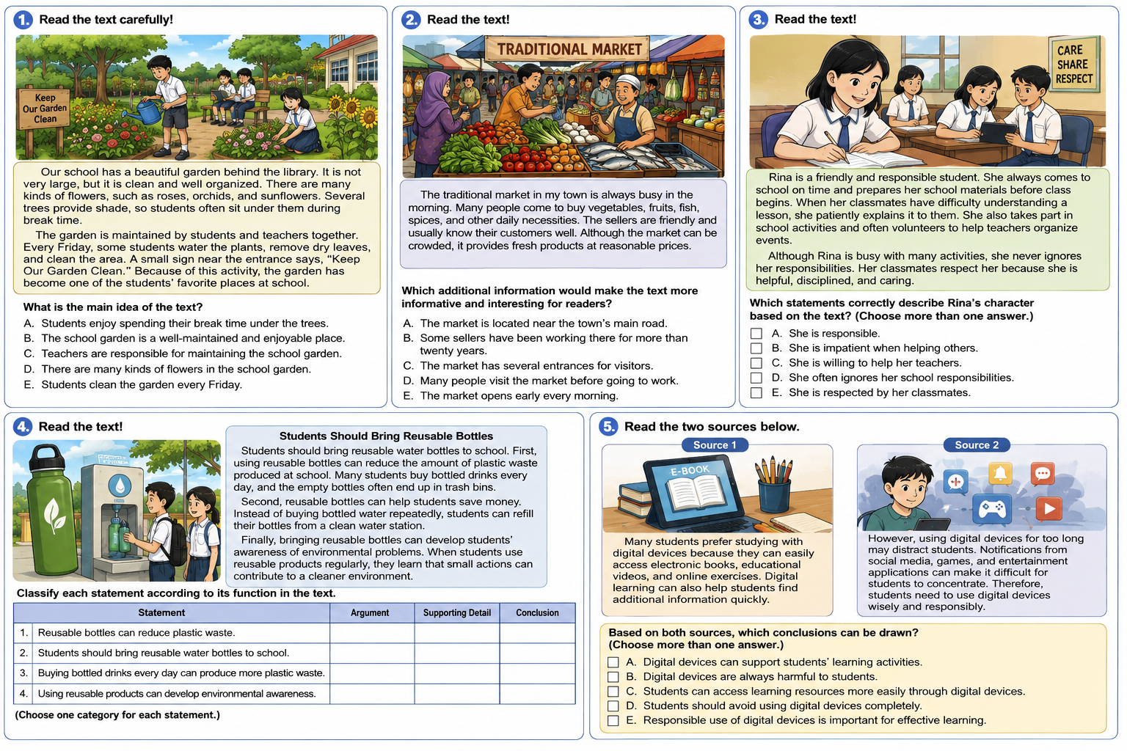

Kunci Jawaban: B

KARTU SOAL NOMOR 18

Mata Pelajaran : Bahasa Inggris
Fase/Kelas : F / XII

Tujuan Pembelajaran | : | Peserta didik mampu menentukan fakta tambahan yang membuat teks lebih informatif, menarik, atau persuasif.
Materi | : | Descriptive Text – Supporting Facts and Additional Information
Indikator Soal | : | Menentukan fakta tambahan agar teks lebih informatif/ menarik/ persuasif pada descriptive text yang menggunakan struktur kalimat sederhana dan beberapa kalimat majemuk dasar dengan konteks sehari-hari.
Level Kognitif  Bentuk Soal | :  : | C5 (Mengevaluasi)  Pilihan Ganda
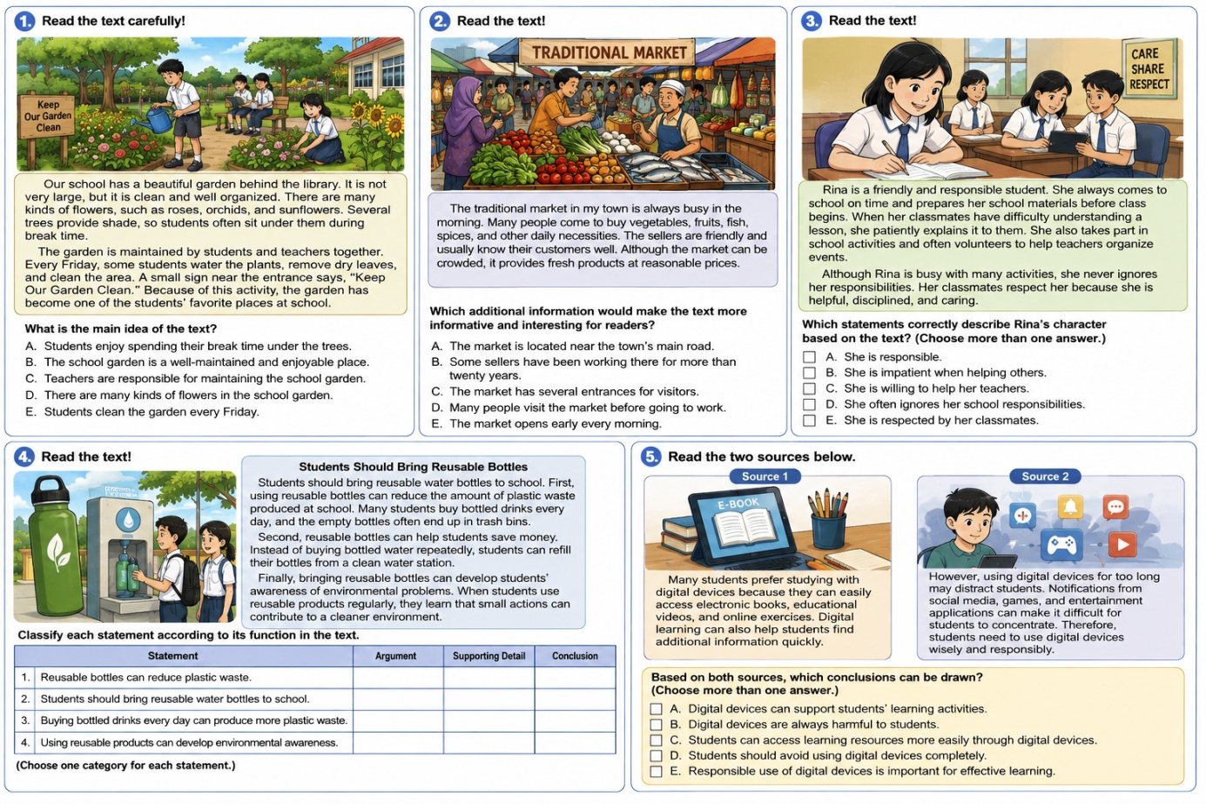

Kunci Jawaban: B
KARTU SOAL NOMOR 19

Mata Pelajaran : Bahasa Inggris
Fase/Kelas : F / XII

Tujuan Pembelajaran | : | Peserta didik mampu menentukan bagian text yang sesuai untuk menggambarkan karakter utama atau aspek lain dari bacaan.
Materi | : | Descriptive Text – Character and Text Details
Indikator Soal | : | Mengevaluasi aspek utama/ aspek lain dalam descriptive text yang menggunakan struktur kaliamat sederhana dan beberapa kalimat majemuk dasar dengan konteks sehari-hari/ vokasional.
Level Kognitif  Bentuk Soal | :  : | C5 (Mengevaluasi)  MCMA

Kunci Jawaban: A, C, E

KARTU SOAL NOMOR 20

Mata Pelajaran : Bahasa Inggris
Fase/Kelas : F / XII

Tujuan Pembelajaran | : | Peserta didik mampu menentukan bagian text yang sesuai untuk menggambarkan karakter utama atau aspek lain dari bacaan.
Materi | : | Descriptive Text – Character and Text Details
Indikator Soal | : | Mengevaluasi aspek utama/ aspek lain dalam descriptive text yang menggunakan struktur kaliamat sederhana dan beberapa kalimat majemuk dasar dengan konteks sehari-hari/ vokasional.
Level Kognitif  Bentuk Soal | :  : | C5 (Mengevaluasi)  MCMA

Kunci Jawaban:
- Argument;
- Conclusion;
- Supporting Detail;
- Argument

KARTU SOAL NOMOR 21

Mata Pelajaran : Bahasa Inggris
Fase/Kelas : F / XII

Tujuan Pembelajaran | : | Peserta didik mampu menentukan bagian text yang sesuai untuk menggambarkan karakter utama atau aspek lain dari bacaan.
Materi | : | Descriptive Text – Character and Text Details
Indikator Soal | : | Mengevaluasi aspek utama/ aspek lain dalam descriptive text yang menggunakan struktur kaliamat sederhana dan beberapa kalimat majemuk dasar dengan konteks sehari-hari/ vokasional.
Level Kognitif  Bentuk Soal | :  : | C5 (Mengevaluasi)  MCMA

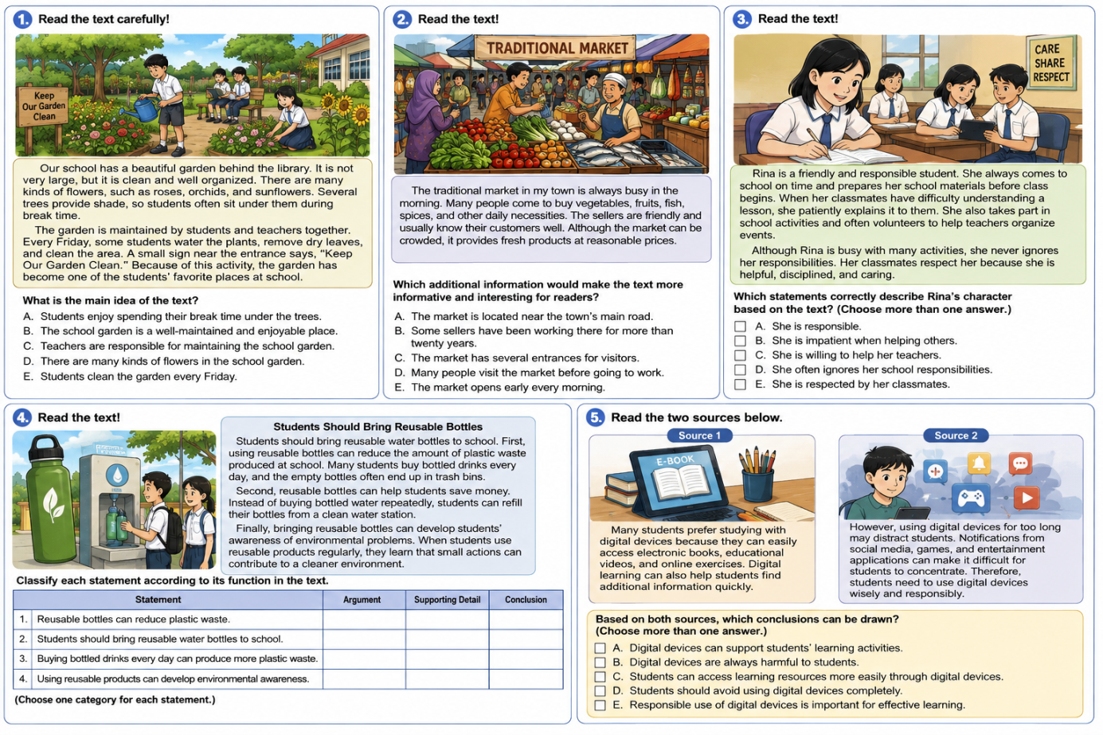

Kunci Jawaban: A, C, E
KARTU SOAL NOMOR 22

Mata Pelajaran : Bahasa Inggris
Fase/Kelas : F / XII

Tujuan Pembelajaran | : | Peserta didik mampu menyimpilkan topik, ide pokok/ gagasan utama, makna, target pembaca pesan moral yang tidak secara eksplisit dinyatakan dalam teks.
Materi | : | Descriptive Text – Main Idea, Topic, Inference, Meaning, Target Reader, and Moral Message
Indikator Soal | : | Menyimpulkan topik descriptive text yang menggunakan struktur kalimat sederhana dan beberapa kalimat majemuk dasar dengan konteks sehari-hari/ vokasional.
Level Kognitif  Bentuk Soal | :  : | C4 (Menganalisis)  Pilihan Ganda

Kunci Jawaban: B

KARTU SOAL NOMOR 23

Mata Pelajaran : Bahasa Inggris
Fase/Kelas : F / XII

Tujuan Pembelajaran | : | Peserta didik mampu menentukan fakta tambahan yang membuat teks lebih informatif, menarik, atau persuasif.
Materi | : | Descriptive Text – Supporting Facts and Additional Information
Indikator Soal | : | Menentukan fakta tambahan agar teks lebih informatif/ menarik/ persuasif pada descriptive text yang menggunakan struktur kalimat sederhana dan beberapa kalimat majemuk dasar dengan konteks sehari-hari.
Level Kognitif  Bentuk Soal | :  : | C5 (Mengevaluasi)  Pilihan Ganda

Kunci Jawaban: B
KARTU SOAL NOMOR 24

Mata Pelajaran : Bahasa Inggris
Fase/Kelas : F / XII

Tujuan Pembelajaran | : | Peserta didik mampu menentukan bagian text yang sesuai untuk menggambarkan karakter utama atau aspek lain dari bacaan.
Materi | : | Descriptive Text – Character and Text Details
Indikator Soal | : | Mengevaluasi aspek utama/ aspek lain dalam descriptive text yang menggunakan struktur kaliamat sederhana dan beberapa kalimat majemuk dasar dengan konteks sehari-hari/ vokasional.
Level Kognitif  Bentuk Soal | :  : | C5 (Mengevaluasi)  MCMA

Kunci Jawaban: A, C, E

KARTU SOAL NOMOR 25

Mata Pelajaran : Bahasa Inggris
Fase/Kelas : F / XII

Tujuan Pembelajaran | : | Peserta didik mampu menentukan bagian text yang sesuai untuk menggambarkan karakter utama atau aspek lain dari bacaan.
Materi | : | Descriptive Text – Character and Text Details
Indikator Soal | : | Mengevaluasi aspek utama/ aspek lain dalam descriptive text yang menggunakan struktur kaliamat sederhana dan beberapa kalimat majemuk dasar dengan konteks sehari-hari/ vokasional.
Level Kognitif  Bentuk Soal | :  : | C5 (Mengevaluasi)  MCMA

Kunci Jawaban:
- Argument;
- Conclusion;
- Supporting Detail;
- Argument

KARTU SOAL NOMOR 26

Mata Pelajaran : Bahasa Inggris
Fase/Kelas : F / XII

Tujuan Pembelajaran | : | Peserta didik mampu menentukan bagian text yang sesuai untuk menggambarkan karakter utama atau aspek lain dari bacaan.
Materi | : | Descriptive Text – Character and Text Details
Indikator Soal | : | Mengevaluasi aspek utama/ aspek lain dalam descriptive text yang menggunakan struktur kaliamat sederhana dan beberapa kalimat majemuk dasar dengan konteks sehari-hari/ vokasional.
Level Kognitif  Bentuk Soal | :  : | C5 (Mengevaluasi)  MCMA

Kunci Jawaban: A, C, E

