LAPORAN KEGIATAN
MUSYAWARAH GURU MATA PELAJARAN (MGMP)
Mata Pelajaran: BAHASA INGGRIS SMK
Semester: I ( GANJIL )
Tahun Pelajaran: 2026/2027

LEMBAR PENGESAHAN
Laporan kegiatan MGMP Mata Pelajaran Bahasa Inggris SMK telah dilaksanakan pada:

Hari/Tanggal : Jum`at 18 September 2026

Tempat : Daring

Laporan ini disusun sebagai bentuk pertanggungjawaban pelaksanaan kegiatan MGMP Bahasa Inggris SMK

Dibuat Oleh,



Ketua MGMP Bahasa Inggris SMK Sekretaris

( IMRON ROSYIDI, S.Pd ) (FITRI ERAWATI, S.S.,M.Hum)
NIP. 198312012009041003 NIP. 197909012011032001

Mengetahui,
Kepala Cabang Dinas pendidikan
Wilayah kabupaten Aceh Tenggara

(JUFRI. RM,S.Pd.,M.Si)
NIP. 19700220 199801 1 001

BAB I
PENDAHULUAN
A. Latar Belakang
Musyawarah Guru Mata Pelajaran (MGMP) merupakan forum profesional bagi guru untuk meningkatkan kompetensi, berbagi pengalaman, menyusun perangkat pembelajaran, dan menyelesaikan berbagai permasalahan pembelajaran.
Melalui kegiatan MGMP diharapkan terjalin kerja sama yang baik antar guru sehingga kualitas pembelajaran semakin meningkat.

B. Dasar Pelaksanaan
- Undang-Undang Nomor 20 Tahun 2003 tentang Sistem Pendidikan Nasional.
- Peraturan Menteri Pendidikan yang berlaku mengenai pengembangan profesi guru.
- Program Kerja MGMP Tahun Pelajaran 2026/2027
- Hasil rapat pengurus MGMP Bahasa Inggris SMK

C. Tujuan
Meningkatkan kompetensi guru.
- Menyamakan persepsi dalam pelaksanaan pembelajaran.
- Menyusun perangkat ajar bersama.
- Menyusun asesmen yang berkualitas.
- Menjalin kolaborasi antar guru.

BAB II
PELAKSANAAN KEGIATAN
Nama Kegiatan : Pertemuan Rutin MGMP Bahasa Inggris SMK
Hari/Tanggal : Jum`at / 18 September 2026
Waktu : 08.00 Wib s/d 15.00 Wib
Tempat : Daring
Jumlah peserta : 11 orang (Absensi Terlampir)
Terdiri dari guru-guru mata pelajaran Bahasa Inggris dari sekolah-sekolah anggota MGMP Bahasa Inggris SMK.

Susunan Acara
08.00–08.30 Registrasi Peserta/Pengisian Absensi Hadir.

08.30–08.45 Pembukaan

08.45–09.00 Sambutan Ketua MGMP

09.00–10.30 Penyampaian Materi

10.30–12.00 Diskusi

12.00–13.30 Ishoma

13.30–14.30 Pembahasan Indikator Soal TKA

14.30–15.00 Penutup

BAB III
HASIL PERTEMUAN
A. Materi yang Dibahas
- Evaluasi program kerja MGMP.
- Membahas Indikator Soal TKA
B. Hasil Keputusan
- Menyusun bank soal bersama.
- Menentukan agenda MGMP bulan berikutnya.
C. Rencana Tindak Lanjut
- Guru menyusun bank soal.
- Melakukan evaluasi pada pertemuan berikutnya.

BAB IV
PENUTUP

Kegiatan MGMP telah berlangsung dengan baik dan lancar. Seluruh peserta mengikuti kegiatan secara aktif sehingga tujuan pertemuan dapat tercapai.
Diharapkan hasil pertemuan ini dapat diterapkan dalam proses pembelajaran di sekolah masing-masing serta menjadi dasar peningkatan kualitas pendidikan secara berkelanjutan.

LAMPIRAN - LAMPIRAN
- Dokumentasi Foto
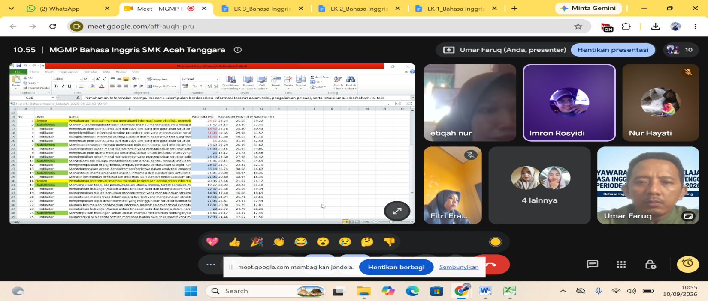

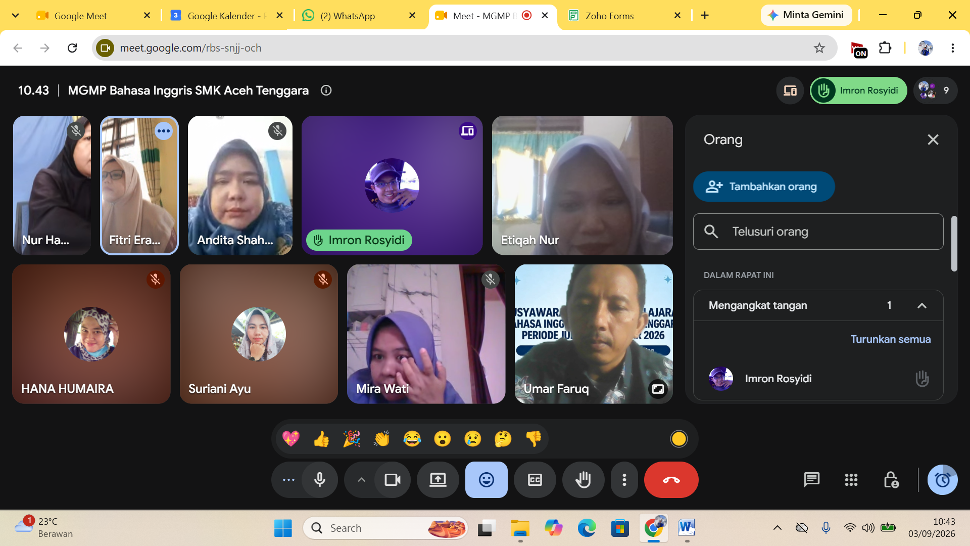

- Pembahasan Soal TKA
- ANALYTICAL EXPOSITION TEXT
KARTU SOAL NOMOR 1

Mata Pelajaran : Bahasa Inggris
Fase/Kelas : F / XII

- Tujuan Pembelajaran: Peserta didik mampu menyimpulkan argumen utama dalam teks eksposisi analitis.
- Materi: Analytical Exposition (Digital Literacy).
- Indikator Soal: Disajikan teks eksposisi, peserta didik dapat menentukan alasan mengapa literasi digital dianggap krusial di era modern.
- Level Kognitif: L3 (Penalaran/Evaluasi).
- Bentuk Soal: MCMA (Pilihan Ganda Kompleks / Checkbox).

The Necessity of Digital Literacy
In the contemporary era, digital literacy is no longer an optional skill but a fundamental necessity. Firstly, the proliferation of "fake news" requires individuals to possess critical thinking skills to verify the credibility of online sources. Without these skills, society becomes vulnerable to misinformation that can influence political and social stability. Secondly, the modern job market increasingly demands proficiency in digital tools. Most professional communications and data management tasks are now conducted through complex digital platforms. Therefore, being digitally literate significantly enhances one's employability and career longevity. From these arguments, it is clear that digital literacy is the backbone of personal and professional success in the $21^{\text{st}}$ century.
Question: Based on the arguments presented, why is digital literacy considered essential? (Select two correct answers)
[A ] It acts as a safeguard against the negative impacts of information manipulation.
[B] It provides a competitive advantage in securing and maintaining employment.
[C] It guarantees that all information found on the internet is accurate and reliable.
[D] It replaces the need for traditional communication skills in the workplace.
[E] It ensures that digital tools will fully automate professional data management.

Key Answers: A and B Explanation:
- A benar merujuk pada argumen pertama tentang menangani "fake news" dan "misinformation."
- B benar merujuk pada argumen kedua tentang "employability and career longevity."
- C salah karena literasi digital tidak menjamin akurasi internet, melainkan membantu verifikasi.
- D salah karena teks tidak menyatakan literasi digital menggantikan kemampuan komunikasi tradisional.
- E salah karena terlalu ekstrem dan tidak dibahas dalam teks.

KARTU SOAL NOMOR 2

Mata Pelajaran : Bahasa Inggris
Fase/Kelas : F / XII
- Tujuan Pembelajaran: Peserta didik mampu mengevaluasi argumen logis penulis mengenai isu lingkungan perkotaan.
- Materi: Analytical Exposition.
- Indikator Soal: Disajikan teks eksposisi, peserta didik dapat menentukan alasan utama mengapa kota modern harus membangun ruang terbuka hijau.
- Level Kognitif: L3 (Penalaran/Evaluasi).
- Bentuk Soal: MCMA (Pilihan Ganda Kompleks / Checkbox).

The Green Urban Imperative

As urban populations swell, cities must prioritize the integration of green spaces like parks and community gardens. First, urban vegetation acts as a natural air filter, absorbing carbon dioxide and trapping harmful particulate matter, which directly mitigates the urban heat island effect. Second, green spaces offer essential psychological relief. Scientific studies show that regular exposure to nature significantly lowers cortisol levels in stressed city dwellers, improving overall community mental health. Therefore, urban planning must view green spaces not as decorative luxuries, but as essential public infrastructure.

Question: Based on the arguments presented, why is the integration of green spaces in modern cities highly essential? (Select two correct answers)
[A] It assists in filtering atmospheric pollutants and regulating local temperatures.
[B] It acts as a natural psychological buffer that benefits citizens' mental well-being.
[C] It completely eliminates the need for modern technological air purification systems.
[D] It serves to increase local municipal revenue through high entry fee collections.
[E] It requires replacing all modern residential buildings with community gardens.

Key Answers: A and B Explanation:
- A benar merujuk pada argumen pertama mengenai penyerapan karbon dioksida dan peredaan efek pulau panas ("mitigates the urban heat island effect").
- B benar merujuk pada argumen kedua tentang penurunan kadar stres/kortisol warga kota ("lowers cortisol levels... improving mental health").
- C salah karena terlalu ekstrem ("completely eliminates").
- D dan E salah karena tidak dibahas dalam teks.

KARTU SOAL NOMOR 3

Mata Pelajaran : Bahasa Inggris
Fase/Kelas : F / XII
- Tujuan Pembelajaran: Peserta didik mampu menyimpulkan implikasi ekonomi dari kurangnya literasi keuangan di kalangan remaja.
- Materi: Analytical Exposition.
- Indikator Soal: Disajikan teks eksposisi, peserta didik dapat mengidentifikasi dampak positif penguasaan literasi keuangan sejak dini.
- Level Kognitif: L3 (Penalaran/Evaluasi).
- Bentuk Soal: MCMA (Pilihan Ganda Kompleks / Checkbox).

The Necessity of Youth Financial Literacy

In today's consumer-driven society, teaching financial literacy to teenagers is critical. With easy access to digital shopping applications and online micro-loans, young people are highly vulnerable to falling into early debt traps. By introducing financial education early, teenagers learn vital skills such as compound interest calculation, realistic budgeting, and investment strategies. This knowledge not only protects them from predatory financial schemes but also fosters long-term financial independence. Consequently, a financially literate youth population leads to a more stable national economy in the future.
Question: Based on the text, what are the primary benefits of introducing financial education to teenagers? (Select two correct answers)
[A] It equips young people with the skills to avoid digital predatory debt patterns.
[B] It directly contributes to broader long-term national economic stability.
[C] It guarantees that teenagers will never experience any form of financial loss.
[D] It replaces the need for young people to seek employment in their adult lives.
[E] It is designed to encourage teenagers to take micro-loans for digital shopping.

Key Answers: A and B Explanation:
- A benar sesuai dengan argumen pertama bahwa edukasi keuangan melindungi remaja dari jeratan utang digital ("protects them from predatory financial schemes/debt traps").
- B benar sesuai dengan kalimat terakhir yang menyatakan pemuda yang melek finansial akan berkontribusi pada ekonomi nasional yang stabil.
- C salah karena tidak ada jaminan bebas kerugian sepenuhnya ("guarantees... never").
- D dan E salah karena tidak rasional dan tidak didukung teks.

KARTU SOAL NOMOR 4

Mata Pelajaran : Bahasa Inggris
Fase/Kelas : F / XII
- Tujuan Pembelajaran: Peserta didik mampu mengevaluasi validitas argumen logis penulis mengenai perlindungan hak cipta manusia di tengah perkembangan kecerdasan buatan (AI).
- Materi: Analytical Exposition.
- Indikator Soal: Disajikan teks eksposisi analitis tentang regulasi hak kekayaan intelektual atas karya seni AI, peserta didik dapat menafsirkan tantangan hukum dan solusi etis yang ditawarkan oleh penulis.
- Level Kognitif: L3 (Penalaran/Evaluasi).
- Bentuk Soal: MCMA (Pilihan Ganda Kompleks / Checkbox).

Guarding the Creative Mind
The explosive rise of Generative Artificial Intelligence (AI) has sparked an intense global debate within the creative sectors. While developers champion AI tools as catalysts for democratization and rapid content generation, the legal and ethical implications for human creators are profound. Our current copyright and intellectual property frameworks are fundamentally ill-equipped to deal with the nuances of algorithmic model training, which routinely scrapes millions of copyrighted artworks without obtaining prior consent, providing attribution, or offering financial compensation.
First, this uncompensated data harvesting dilutes the economic value of human labor. When an AI can instantly replicate an illustrator's highly refined, signature style based on thousands of stolen reference images, the human artist is effectively forced to compete against a computational mimic of their own identity. Second, current copyright laws historically protect human authorship. Granting copyrights to AI-generated images or allowing developers to profit from datasets without a balanced licensing structure threatens the economic survival of professional creators. Therefore, to preserve the integrity of human intellectual expression, we must establish a rigorous, mutually beneficial licensing ecosystem that enforces fair-use standards, protects creative control, and rewards the human foundations upon which modern AI models are built.

Question: Based on the arguments presented, which of the following viewpoints does the author support regarding generative AI regulation? (Select two correct answers)
[A] Current copyright regulatory frameworks are struggling to address the complexities of algorithmic learning
from copyrighted datasets.
[B]Fostering mutually beneficial licensing structures can help protect creative control while embracing
modern technological integration.
[C] Human artistic expression is completely devoid of cognitive value in comparison to generative artificial intelligence.
[D]Implementing strict international bans on all creative AI software is the most viable path to artistic
economic recovery.
[E]Developers are already paying sufficient royalties to all artists whose works are scraped.

Key Answers: A and B Explanation:
- A benar karena paragraf pertama menyatakan kerangka hukum hak cipta saat ini sangat tidak siap menghadapi kerumitan pelatihan model algoritma AI ("current copyright and intellectual property frameworks are fundamentally ill-equipped...").
- B benar karena penulis menyimpulkan perlunya ekosistem lisensi yang saling menguntungkan untuk menjaga kontrol kreatif manusia ("establish a rigorous, mutually beneficial licensing ecosystem that enforces fair-use standards, protects creative control...").
- C salah karena sangat kontradiktif dengan pembelaan penulis terhadap nilai ekspresi manusia.
- D salah karena penulis menyarankan solusi berupa regulasi/lisensi berimbang ("mutually beneficial licensing ecosystem"), bukan pemblokiran internasional total terhadap teknologi AI.
- E salah karena bertentangan dengan isi paragraf pertama.

KARTU SOAL NOMOR 5
Mata Pelajaran : Bahasa Inggris
Fase/Kelas : F / XII

- Tujuan Pembelajaran (TP): Peserta didik mampu menganalisis dan menghubungkan informasi antara teks eksposisi (analytical exposition text) dan data visual (grafik) berbahasa Inggris secara tepat untuk menemukan bukti pendukung argumen penulis.
- Materi Pokok: Analytical Exposition Text with Graphic/Data Presentation: Mengidentifikasi tesis penulis, menganalisis data statistik/grafik penunjang, serta menyimpulkan hubungan korelasi antarvariabel berdasarkan teks dan data.
- Level Kognitif: C4 (Menganalisis / Analyzing) – Peserta didik dituntut untuk mengomparasikan klaim argumen di dalam teks dengan tren data pada grafik, lalu memilah pernyataan mana yang valid didukung oleh kedua instrumen tersebut.
- Bentuk Soal: Pilihan Ganda Kompleks (Memilih 2 jawaban yang benar) / Multiple Choice Multiple Answer (MCMA).

Should Schools Limit Students' Daily Screen Time?

Many educators believe that schools should encourage students to reduce their daily recreational screen time. While digital technology supports learning, excessive use of smartphones and social media outside school hours has been linked to lower academic performance, sleep problems, and reduced physical activity. Therefore, schools should educate students about healthy digital habits instead of simply banning technology.
A survey involving 500 senior high school students examined the relationship between average daily recreational screen time and the percentage of students who achieved an average score above 85 in their semester examinations.
Average Daily Screen Time and High Academic Achievement
Percentage of students scoring above 85 based on average daily recreational screen time.
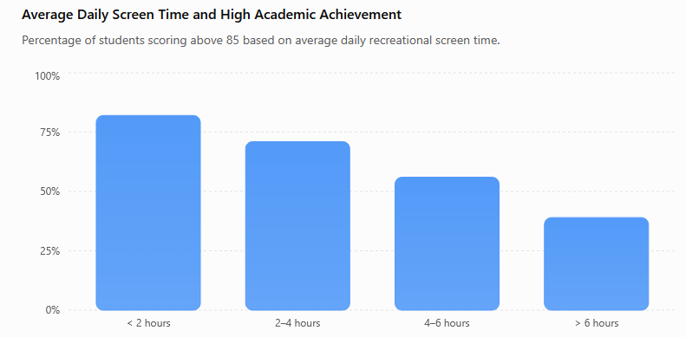

Which TWO statements are best supported by BOTH the analytical exposition text and the graph?
[A] Students who spend less than two hours per day on recreational screen activities are more likely to achieve
high academic scores.
[B] The graph proves that reducing screen time alone will definitely improve every student's academic performance.
[C] The evidence supports the author's argument that healthy digital habits should be promoted in schools.
[D] Students who use screens for more than six hours per day always fail to achieve scores above 85.
[E] The graph indicates that academic achievement tends to decrease as recreational screen time increases.
Jawaban : A&C

- Presensi Kehadiran

Presensi Kehadiran MGMP BAHASA INGGRIS SMK ACEH TENGGARA

Nama | Imron Rosyidi, S.Pd
NIP | 198312012009041003
Asal Sekolah | SMK Negeri 1 Kutacane
Tanda Tangan | 
Added Time | 18-Sep-2026 07:38:17
Referrer Name
Task Owner | umarfruq.83@gmail.com

Nama | Juliana,S.Pd
NIP | 198618102026212005
Asal Sekolah | SMKN 1 Kutacane
Tanda Tangan | 
Added Time | 18-Sep-2026 10:13:37
Referrer Name
Task Owner | umarfruq.83@gmail.com

Nama | Etiqah Nur
NIP | 198108312022212008
Asal Sekolah | SMKN 4 KUTACANE
Tanda Tangan | 
Added Time | 18-Sep-2026 10:08:08
Referrer Name
Task Owner | umarfruq.83@gmail.com

Nama | Suriani
NIP | 198608182009042008
Asal Sekolah | SMKN1 Kutacane
Tanda Tangan | 
Added Time | 18-Sep-2026 09:52:50
Referrer Name
Task Owner | umarfruq.83@gmail.com

Nama | Raja Fauziah, S.Pd
NIP | 19880125 202321 2 022
Asal Sekolah | SMK N 2 Kutacane
Tanda Tangan | 
Added Time | 18-Sep-2026 09:37:29
Referrer Name
Task Owner | umarfruq.83@gmail.com

Nama | Budianti Amran, S. Pd
NIP | 198708152022212005
Asal Sekolah | SMK PP NEGERI KUTACANE
Tanda Tangan | 
Added Time | 18-Sep-2026 09:12:15
Referrer Name
Task Owner | umarfruq.83@gmail.com

Nama | UMAR FARUQ
NIP | 198312222022211006
Asal Sekolah | SMK Negeri Darul Hasanah
Tanda Tangan | 
Added Time | 18-Sep-2026 08:42:22
Referrer Name
Task Owner | umarfruq.83@gmail.com

Nama | Wirda Maiyani
NIP | 198805212023212032
Asal Sekolah | SMK N 2 KUTACANE
Tanda Tangan | 
Added Time | 18-Sep-2026 08:27:35
Referrer Name
Task Owner | umarfruq.83@gmail.com

Nama | Novita Indah Sari
NIP | 198411212009042004
Asal Sekolah | SMKN 1 KUTACANE
Tanda Tangan | 
Added Time | 18-Sep-2026 08:06:29
Referrer Name
Task Owner | umarfruq.83@gmail.com

Nama | Selvianita Rahayu
NIP
Asal Sekolah | SMKS Anak Bangsa
Tanda Tangan | 
Added Time | 18-Sep-2026 08:00:15
Referrer Name
Task Owner | umarfruq.83@gmail.com

Nama | NURHAYATI, S.S
NIP | 197905242014032001
Asal Sekolah | SMKN 1 KUTACANE
Tanda Tangan | 
Added Time | 18-Sep-2026 07:51:15
Referrer Name
Task Owner | umarfruq.83@gmail.com

